 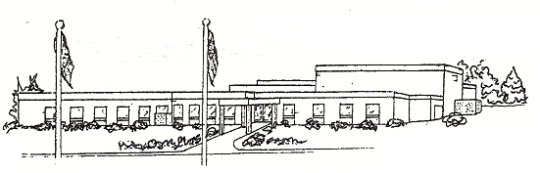

*Every Child, Every Day!*

***9172 James Madison Highway Fork Union, Virginia 23055 (434) 842-1241 (434) 842-1186 Fax*** [***www.fluco.org***](http://www.fluco.org/carysbrook/SitePages/index.aspx)

**Bus Pass / Dismissal Note**

**Bus passes and dismissal changes need to be in prior to 11:00 a.m.**

Date:_____________________

Student:______________________________________________________________

Homeroom Teacher:___________________________________________________

**Bus Number**:______________________

Address of Bus stop:_________________________________________________________________________

(Complete physical address required for bus drivers)

Picked up at bus stop by:______________________________________________________________________

(Name of person that will be picking up student from bus stop)

Student Permission to get off at the stop without an adult present Yes or No

**Afternoon Dismissal** (Located at the right side of the building)

Picked up by:_________________________________________________________________

(Name of person that will be picking up student)

Parent/Guardian Signature:_______________________________________________

Parent/Guardian Daytime Phone Number:_________________________________

**PICK UP LOOP PROCEDURES FOR MORNING DROP-OFF AND AFTERNOON PICKUP**

Separation of Bus and Car Drop-Off Areas for Children - The mixing of cars and buses in front of the school as children are dropped off presents a safety concern for all of us. Due to the limited area around the school, parents are asked not to park in the front bus ramp but use the side and back parking lots when visiting or picking up your child.